Google books api – extract of a tutorial - Jquery

1. Add an input with an ID
2. Add a button with an ID
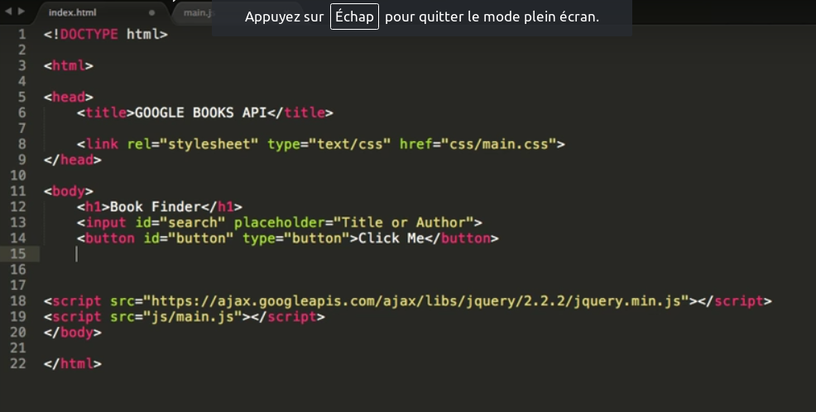

3.Add a div to display the result
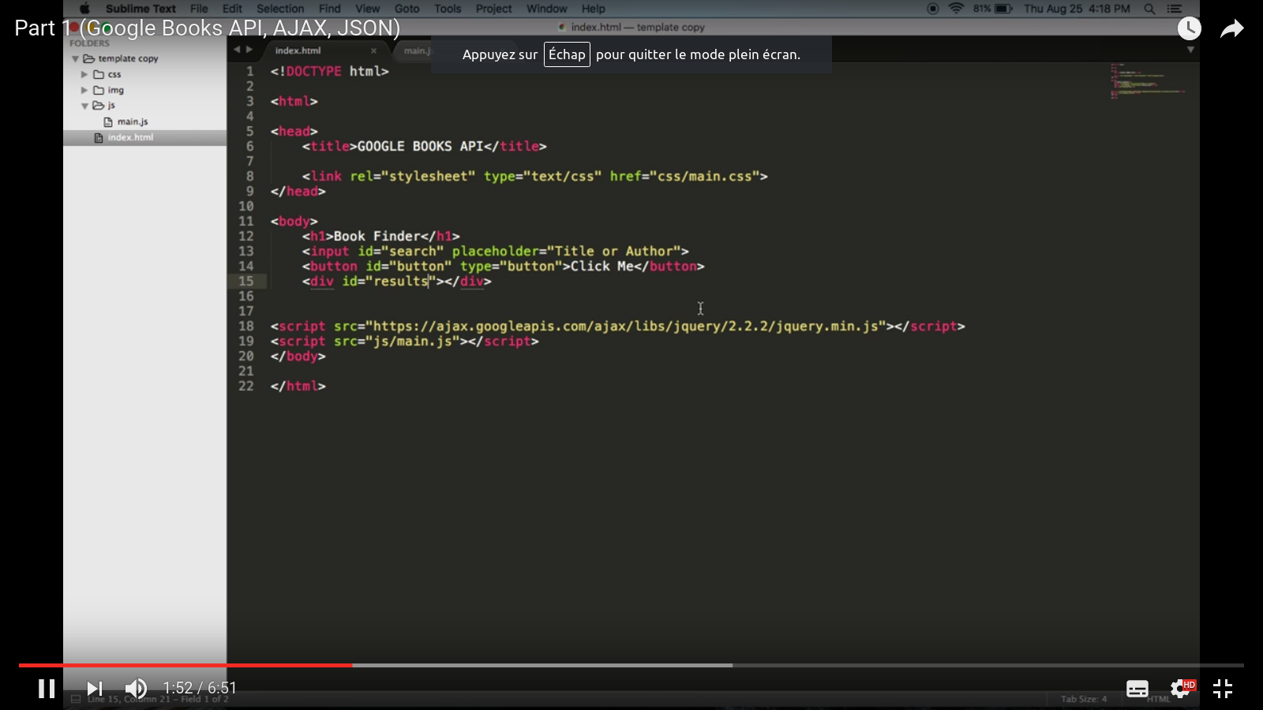

To the Javascript :
4. write the function on the top
5. target the id button and add a add EventListener click + bookSearch function + false to avoid the bubbling
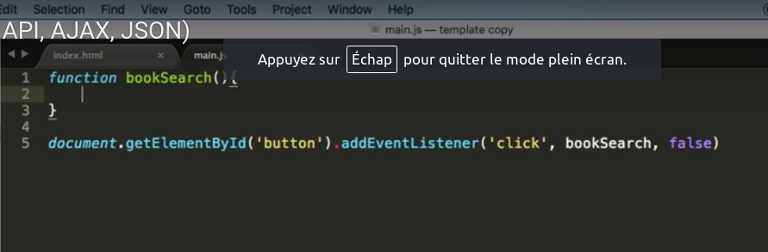
6. write a variable which targets the input id search with the value content
7. target the div results with getElementbyId + add a innerHTML
8.add a console.log to the var search
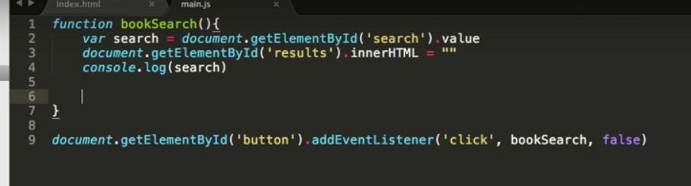
9.create an ajax call
10.in the object, add the url:«https://www.googleapis.com/books/v1/volumes?q=» (?q= means the query or search) with the var search
11.add the dataType that we’re going to use ‘json’
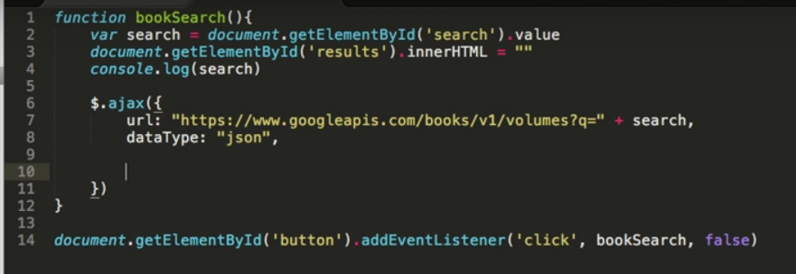
12.
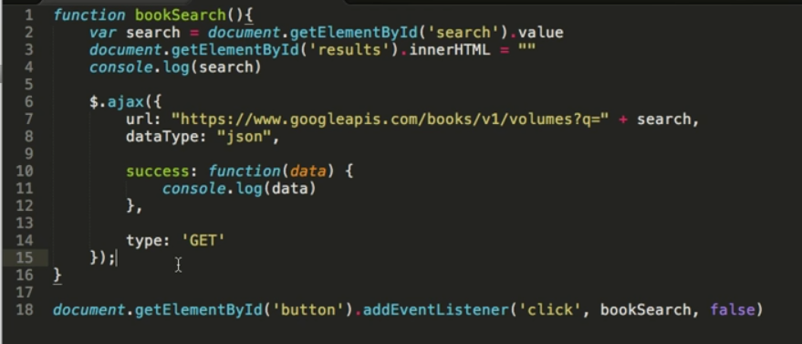

//END OF THE FIRST PART//

